SOUTHERN UNIVERSITY COLLEGE
{
SEMESTER C
{

Please choose one. For 2nd set, choose RESIT.

YEAR 2024
{
FINAL / RESIT / SPECIAL EXAMINATION
{
MARKING SCHEME
{
UESC1113 ATOMIC STRUCTURE, BONDING AND PERIODICITY
{
DATE : DURATION : 2 / 2.5 / 3 HOURS
{
BACHELOR OF SCIENCE (HONS.) BIOTECHNOLOGY
BACHELOR OF SCIENCE (HONS.) CHEMISTRY
{
YEAR ONE

Tab 0.5 for 6 times.

Resit & 2nd set, leave the date blank.

Make sure footer is correct.

In bracket

Capital letter

Number starting by 2

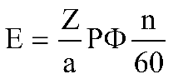
Q1. (a) Derive the expression for induced EMF: for a DC machine.
(11 marks)

Tab 0.5

{
{
(b) A 50 kW, 250 V DC machine has armature and field resistances of 0.02 ∧ and 50∧ . Calculate the following considering the machine working first as a generator and then as a motor. The brush contact drop per brush is 1V.
{
- line current/load current
{

1 space bar before and after the colon ( : )

- shunt field current
{
- armature current
(14 marks)
[Total : 25 marks]
{
A1.

Rotation of the armarure winding in the air gap magnetic field induces a voltage known as armature EMF and commonly referred to as the generated EMF in a generator and the counter EMF in a motor.

Let
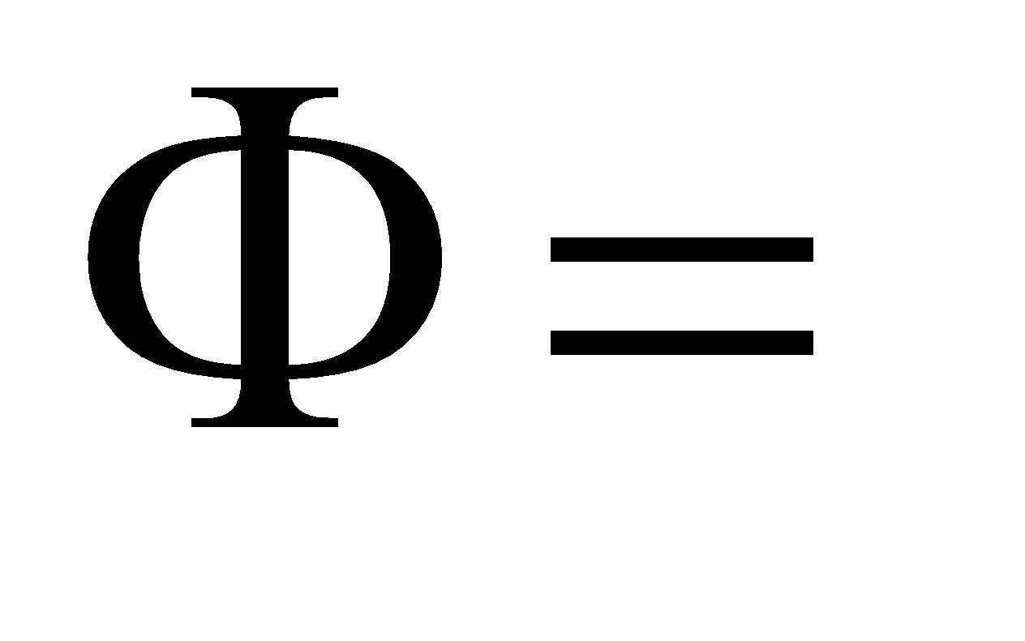useful flux per pole
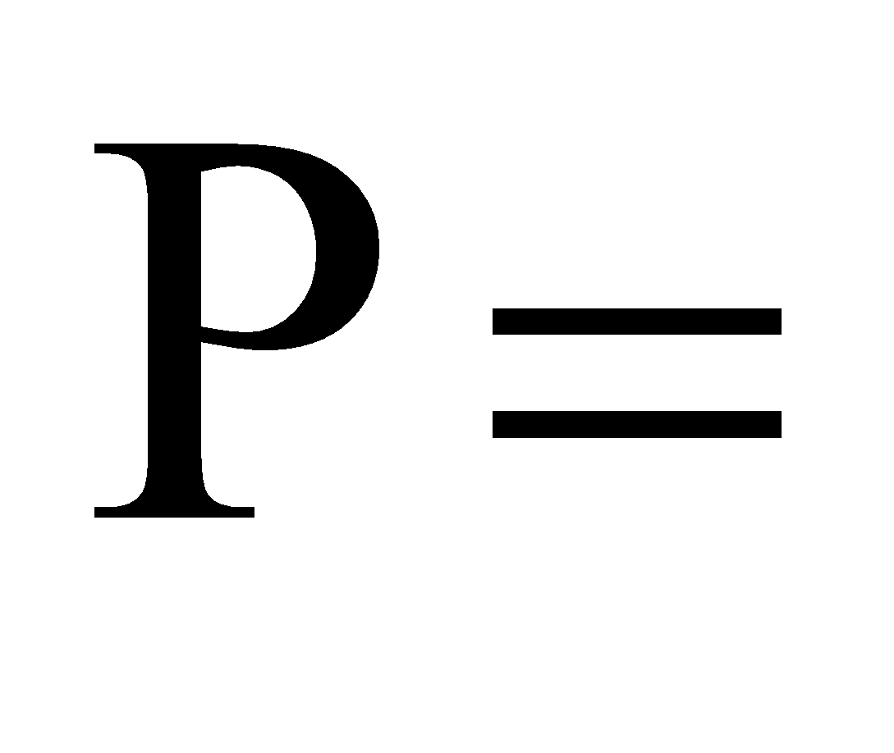number of poles
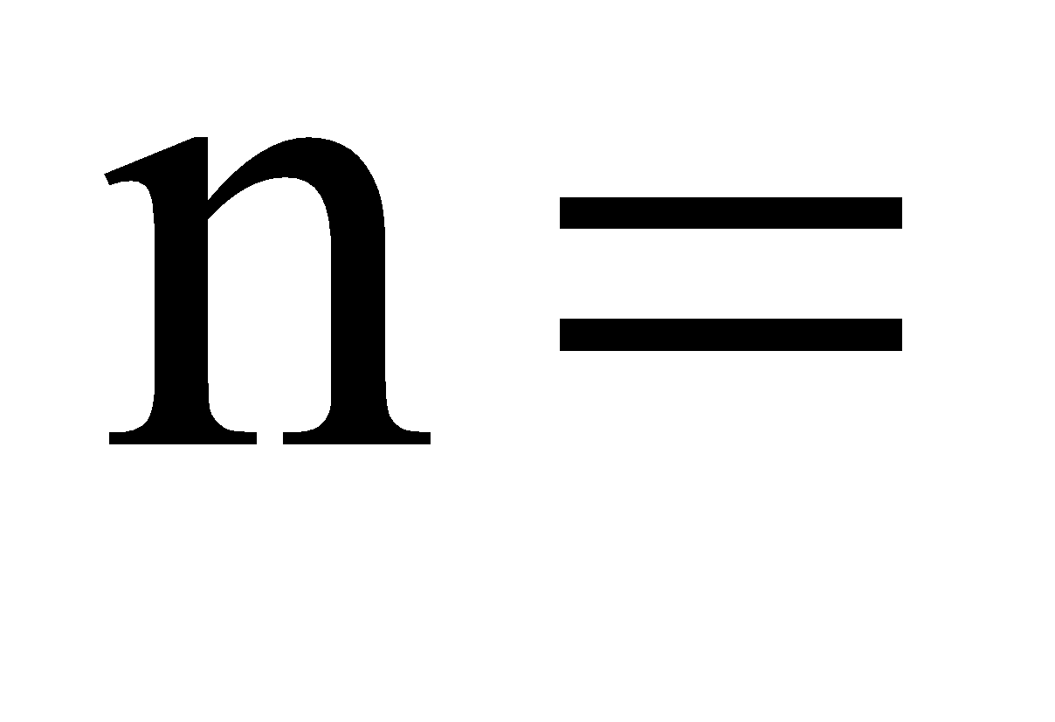speed of rotation of rotor (armature) in rpm

Total flux cut by a conductor in one revolution
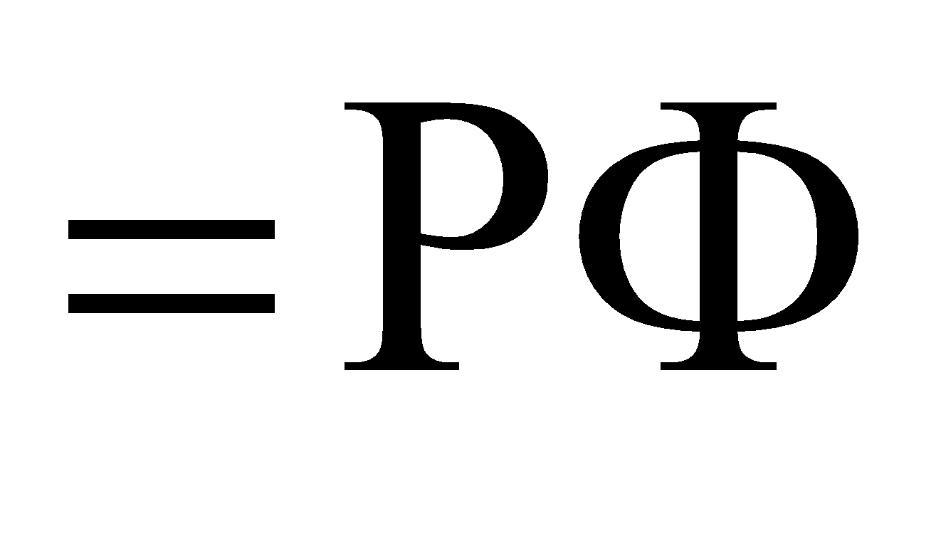

The average rate at which a conductor cuts flux is
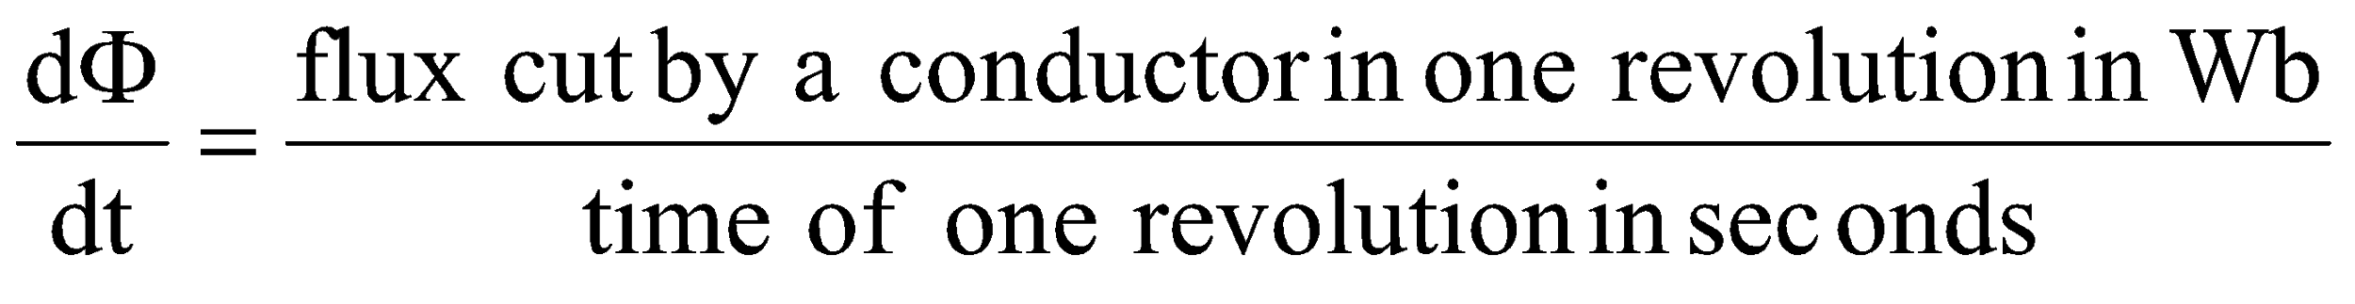
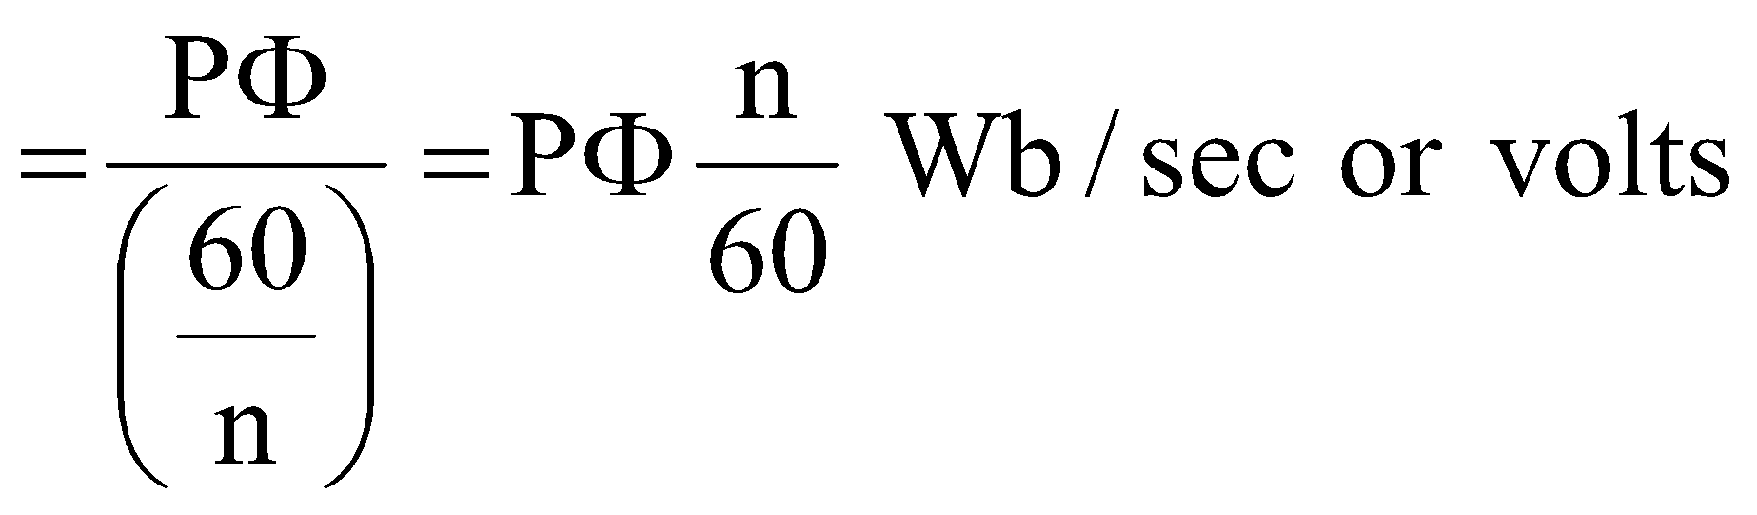 (6 marks)
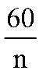
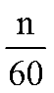
Since revolutions are made in one second, one revolution will be made in seconds.

Let
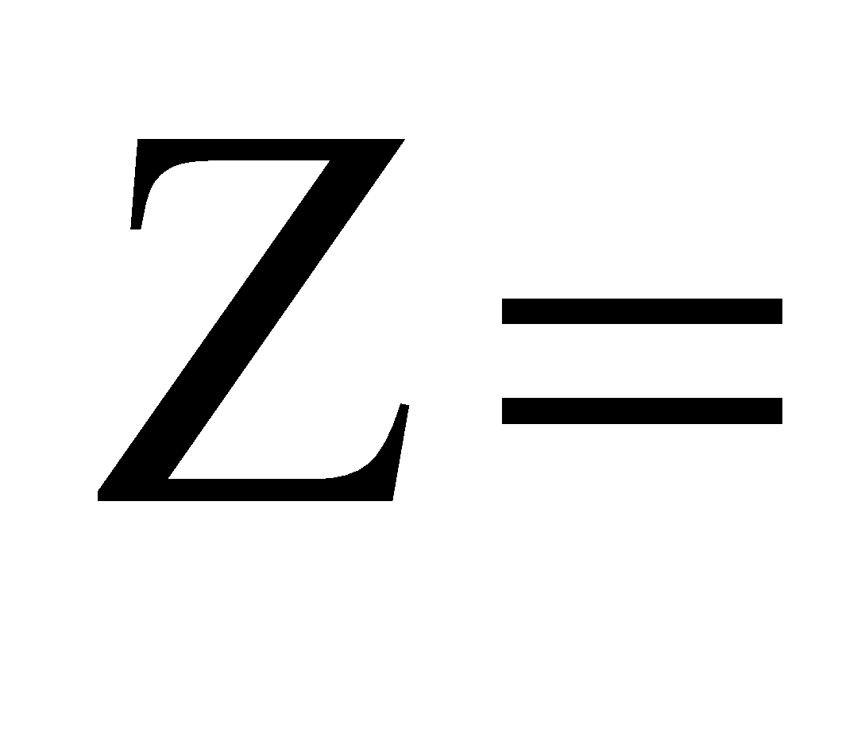number o armature conductors
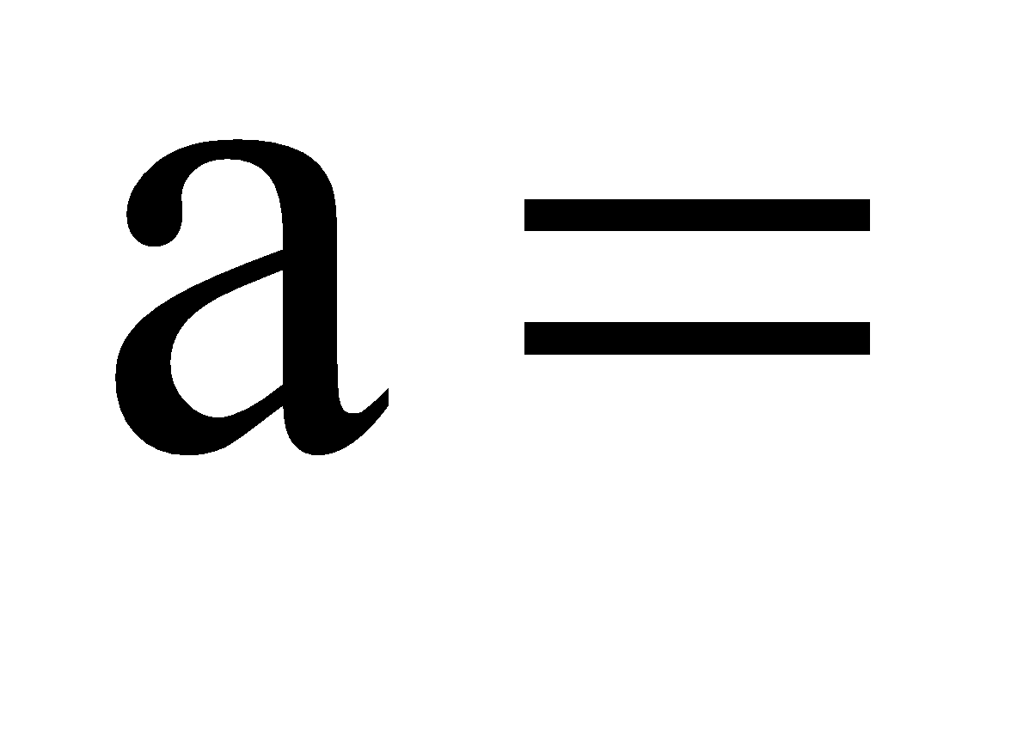number of parallel paths through the armature between the
brushes of opposite polarity

Therefore, number of armature conductors in series in each parallel path
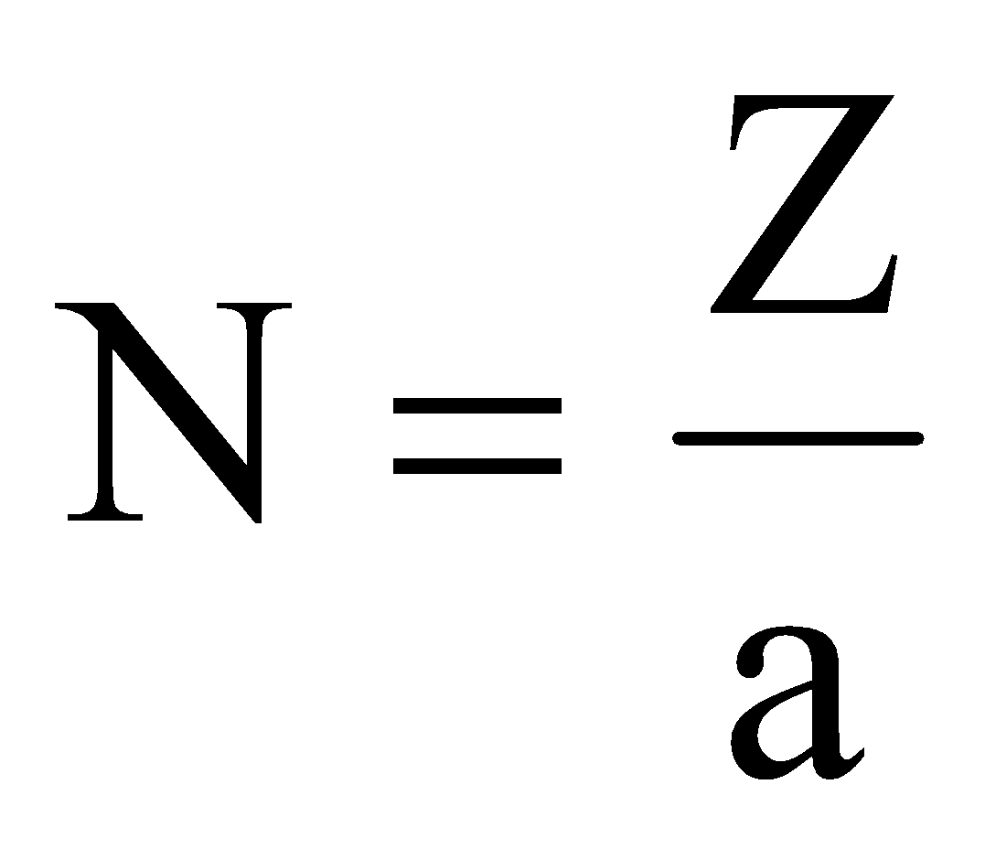
In accordance with Faraday’s law, the induced emf in the armature

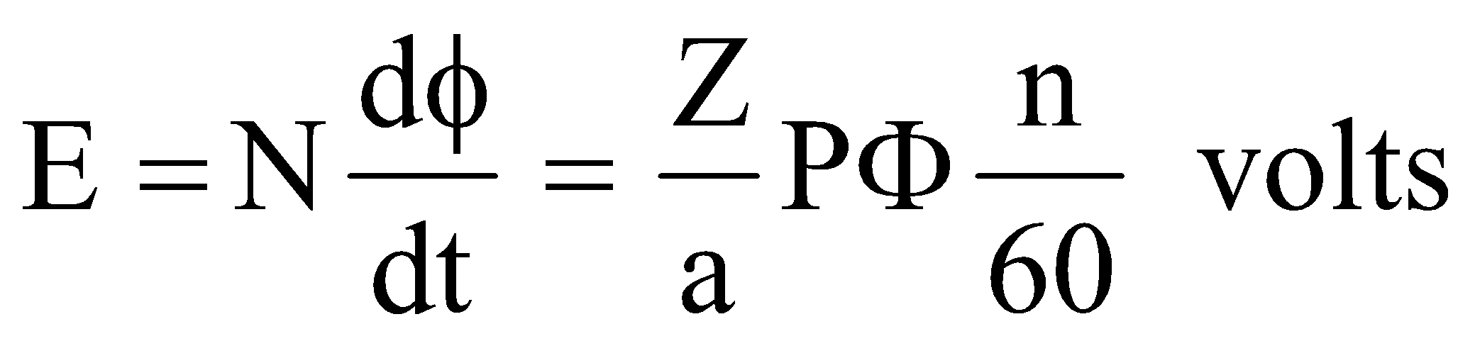 (5 marks)
{
{

As generator
Load current
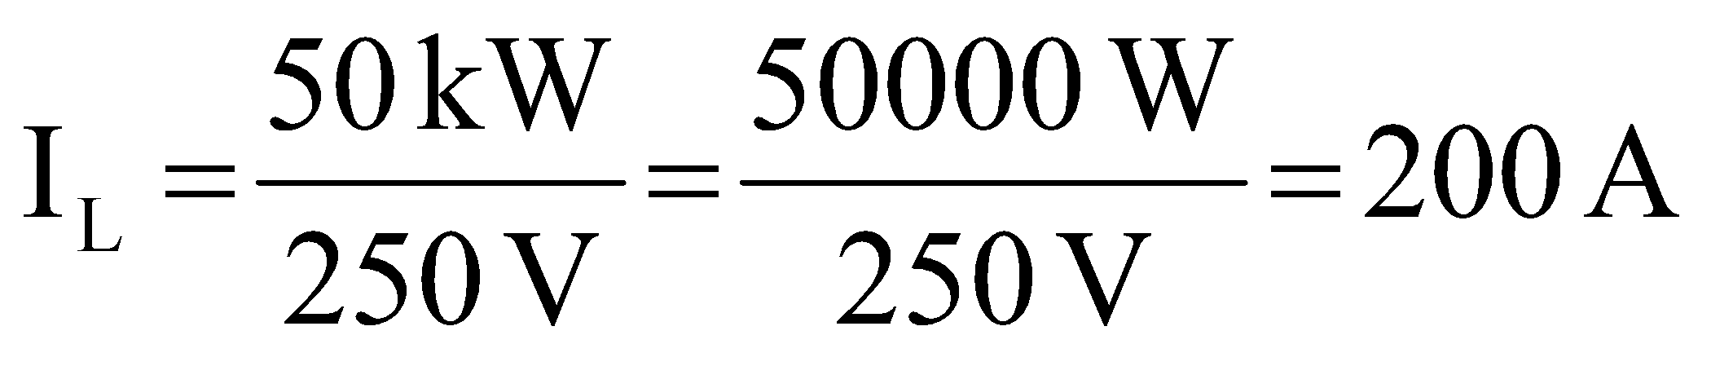 (2 marks)
Shunt field current
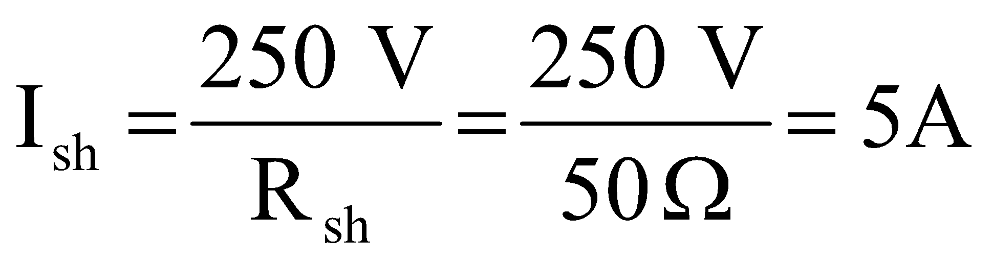 (2 marks)
Armature current
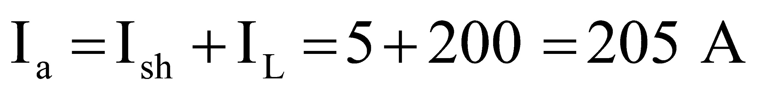 (1 mark)
emf generated
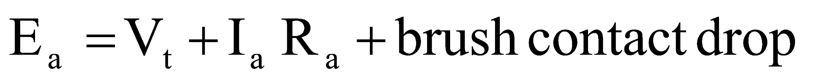
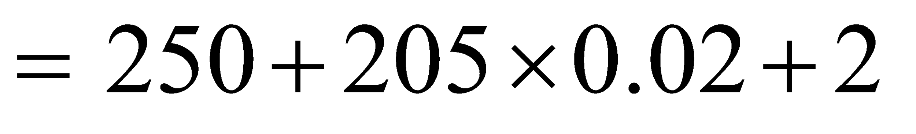
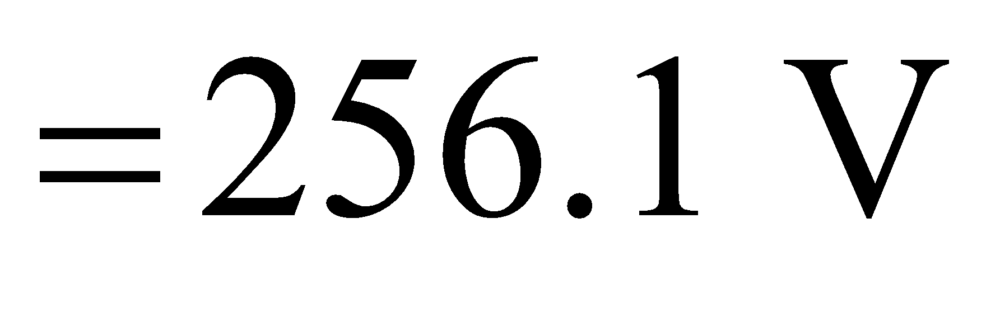 (2 marks)

As motor
Line current
(2 marks)
Shunt field current
(2 marks)
Armature current
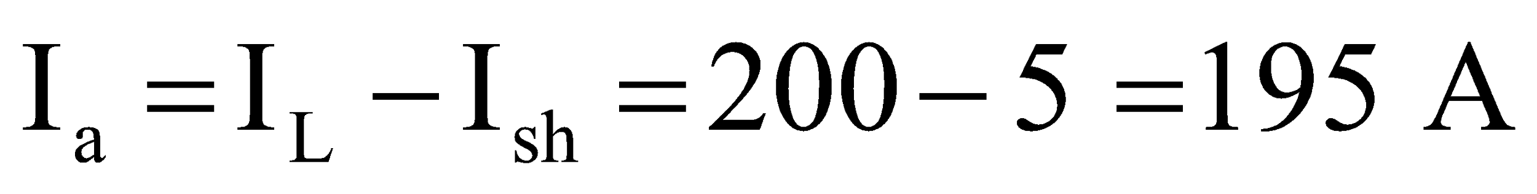 (1 mark)
emf generated

1 space bar before and after the colon ( : )

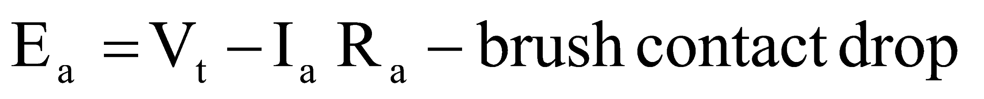
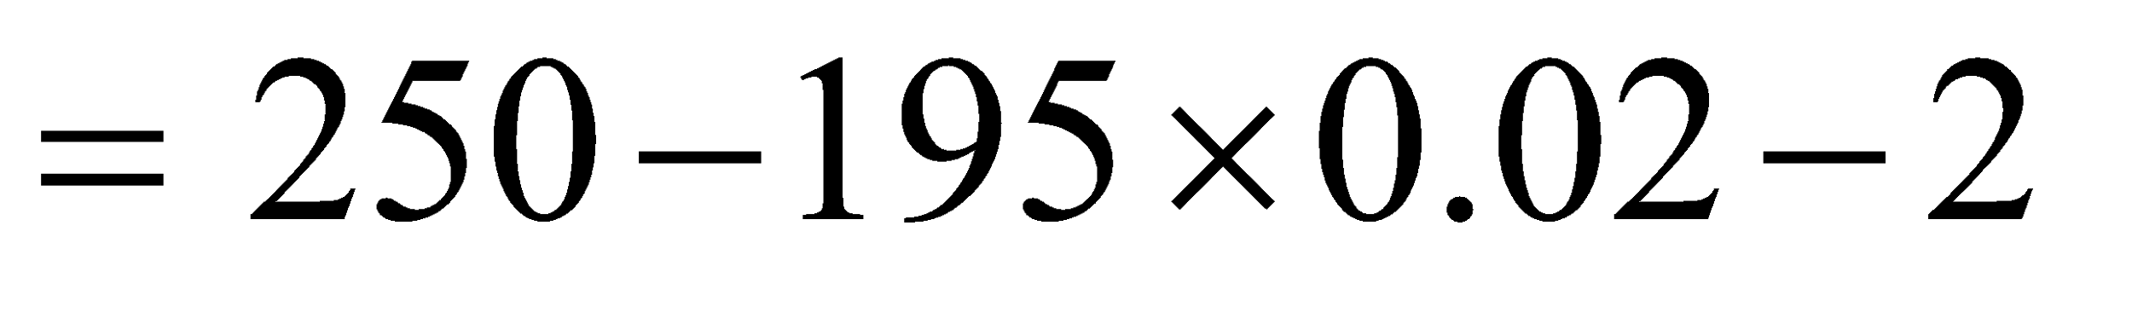
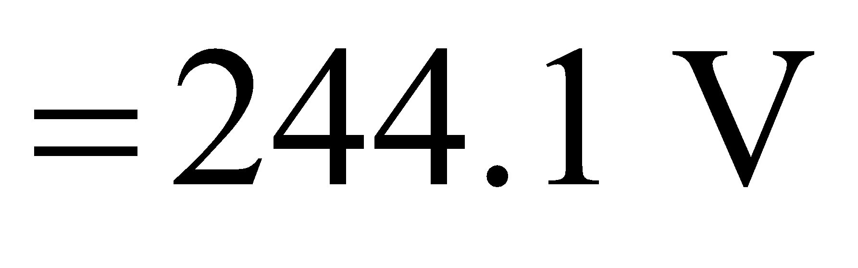 (2 marks)
[Total : 25 marks]
{
{
{
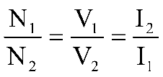
Q2. (a) For an ideal transformer prove that
(13 marks)
{
{
(b) An ideal transformer is used to step down the voltage of a 13.8 kV circuit
to 2300 V. It is fully loaded when it delivers 40 kVA.
{
- Find the turns ratio and rated currents for each winding.
{
- Find the magnitude of load impedance corresponding to full load referred to low voltage and high voltage sides.
(12 marks)
[Total : 25 marks]
{
A2.
(a)
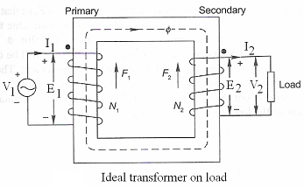
Fig. shows the schematic diagram of an ideal transformer having two windings with N₁ and N₂ turns. A sinusoidal voltage with rms value V₁ and frequency f is applied to the primary winding. The common flux linking the two windings is Ф, which gives rise to the induced emfs E₁ and E₂ on the primary and secondary sides.

The instantaneous value of the common flux Ф can be written as
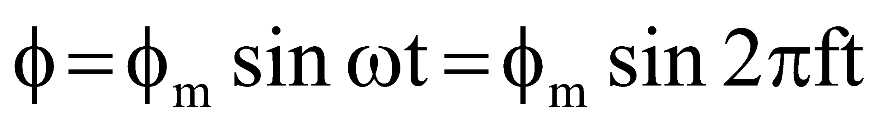
The induced emfs are proportional to the rate of change of flux. Hence the instantaneous values of induced emfs, in accordance with Faraday’s law, are

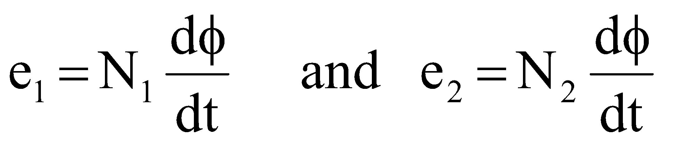

Therefore,

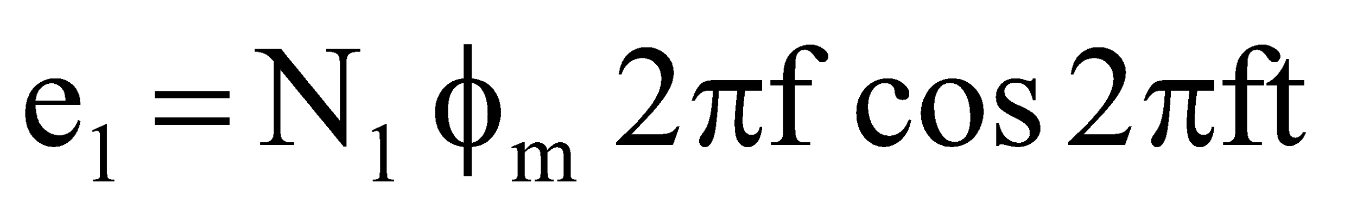
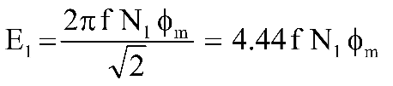
and its rms value is

Similarly,
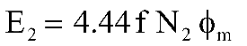

(7 marks)

Applying Kirchoff’s voltage law to the primary and secondary circuits we have

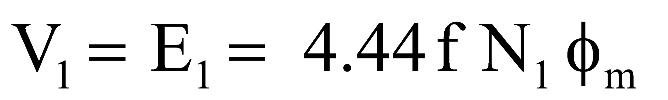

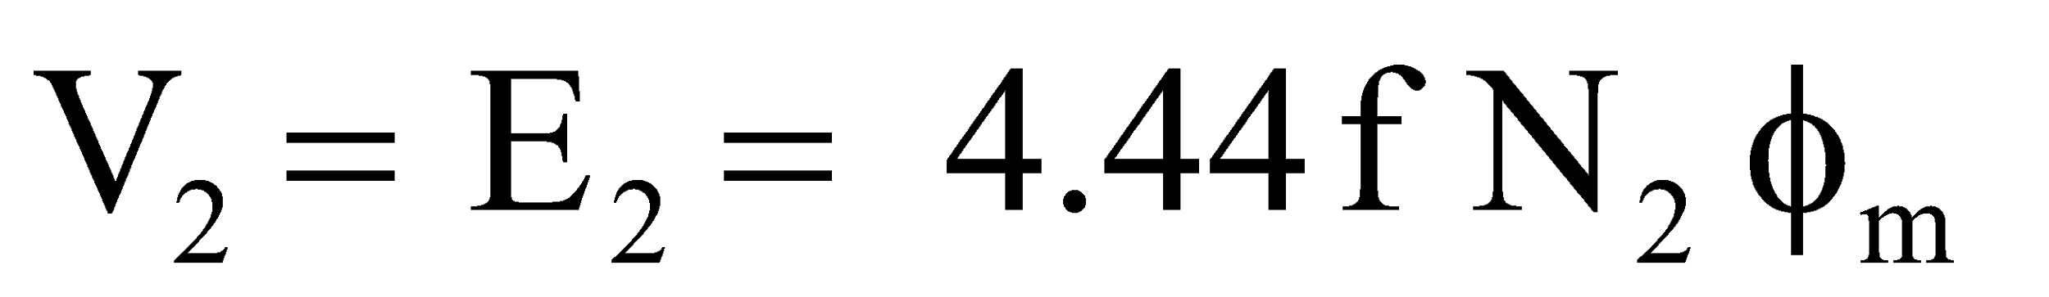

From the above two equations

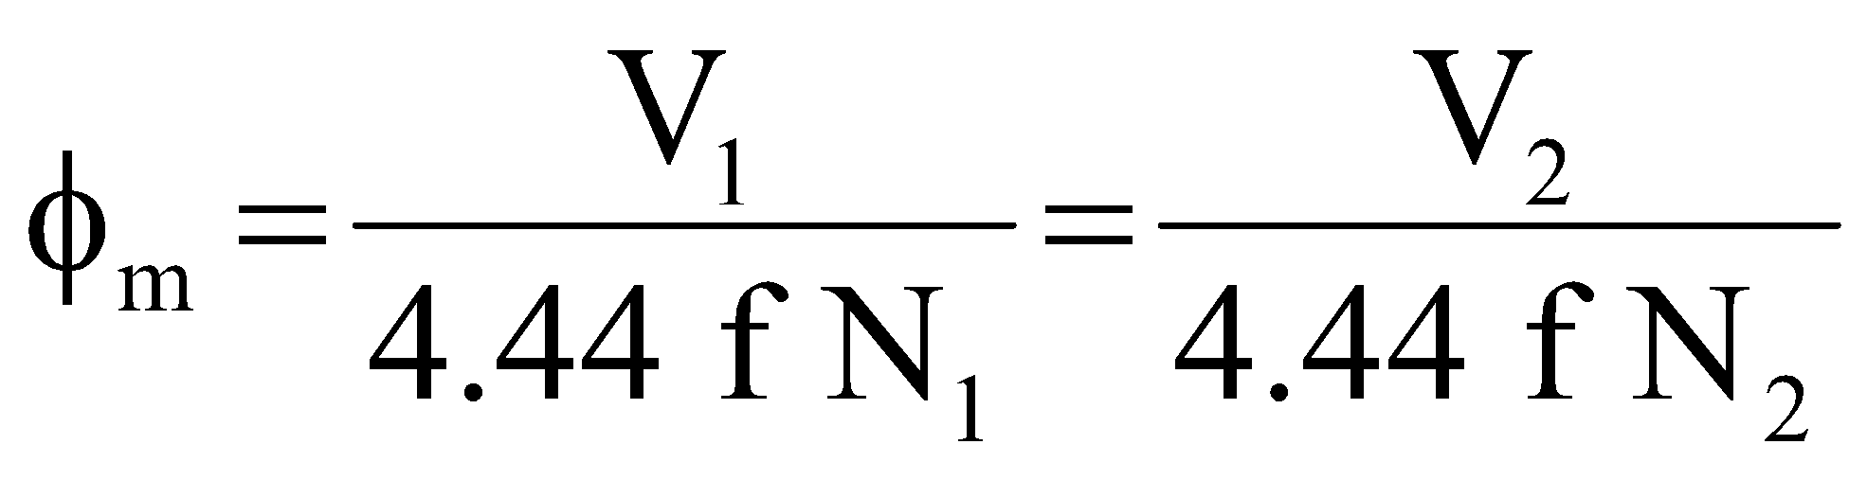

which implies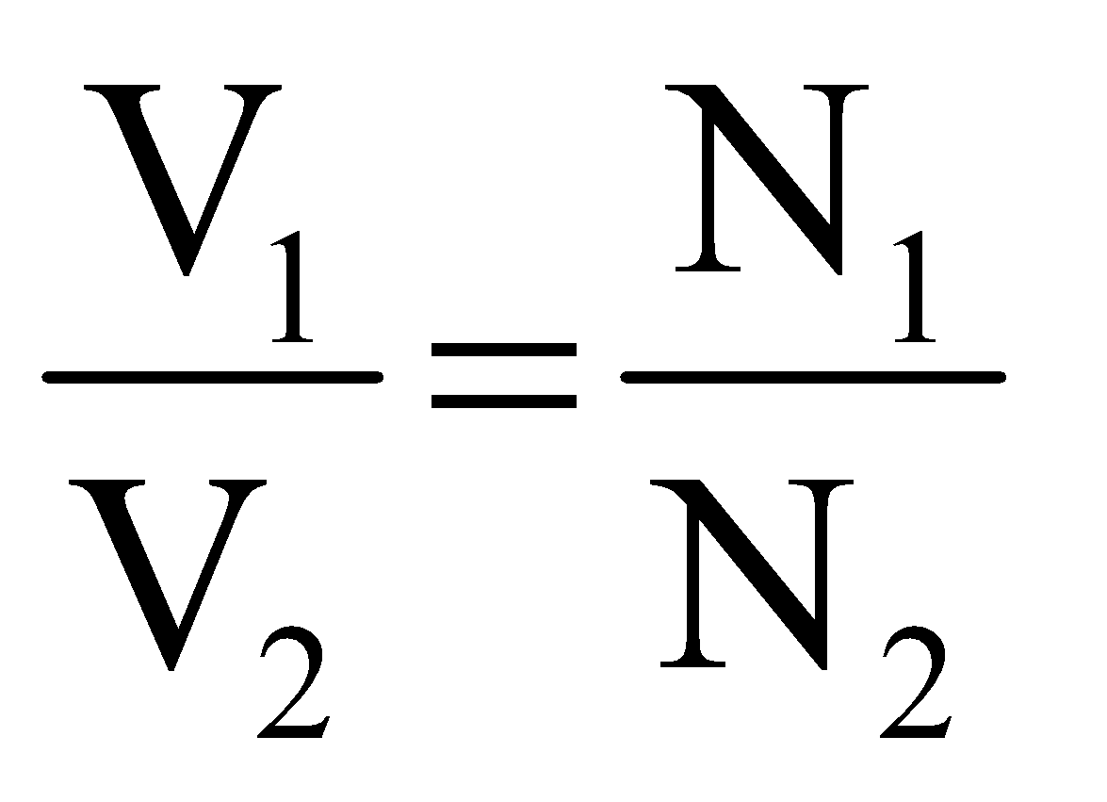

Now, for an ideal transformer the primary and secondary ampere-turns are equal. Therefore,

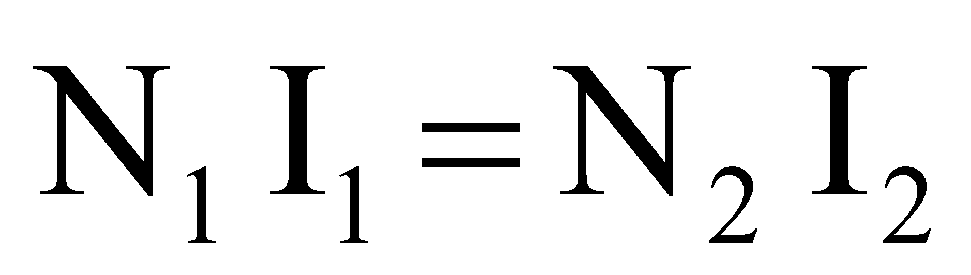

which implies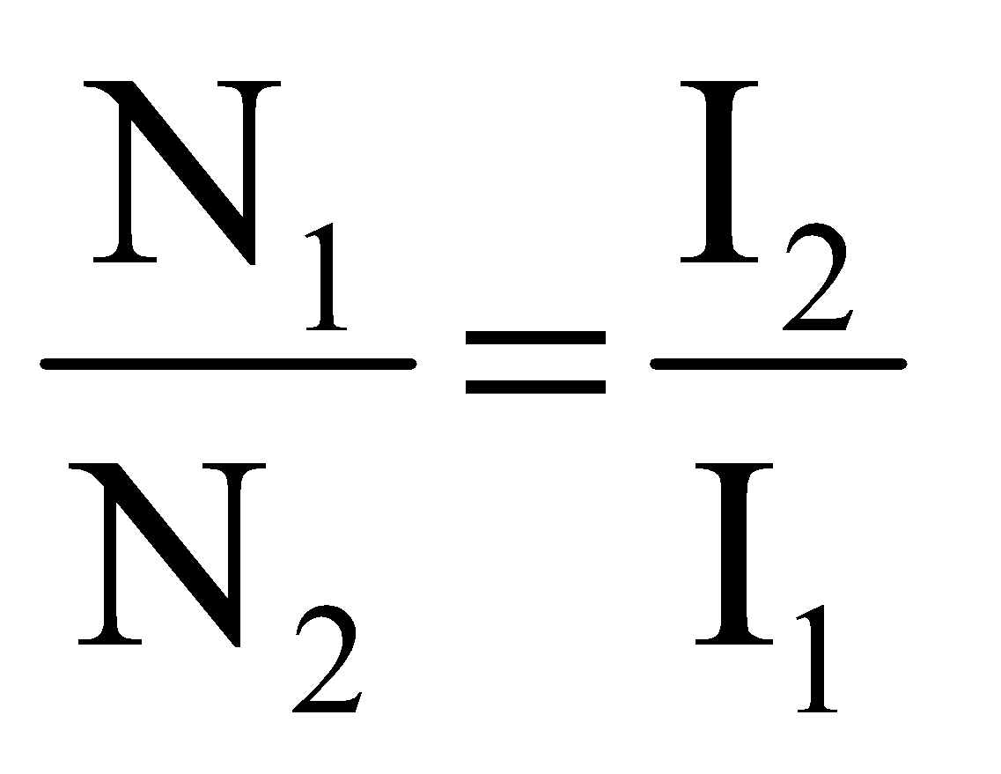

Therefore,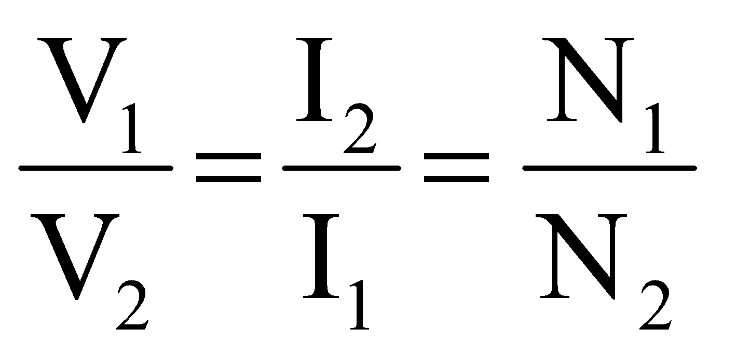

(6 marks)
{
{
(b)
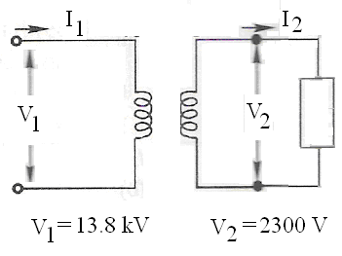

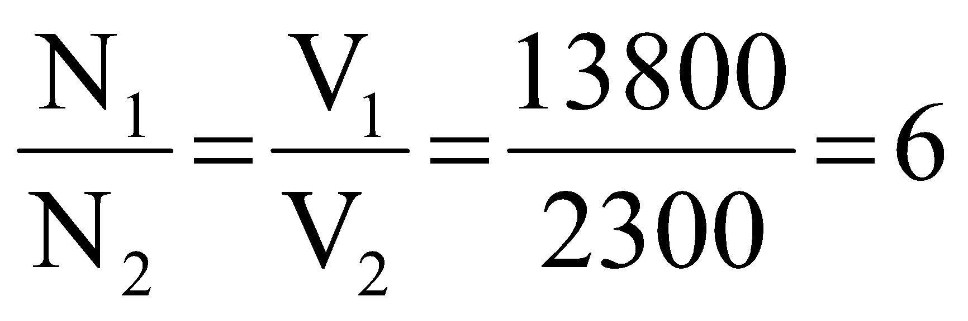
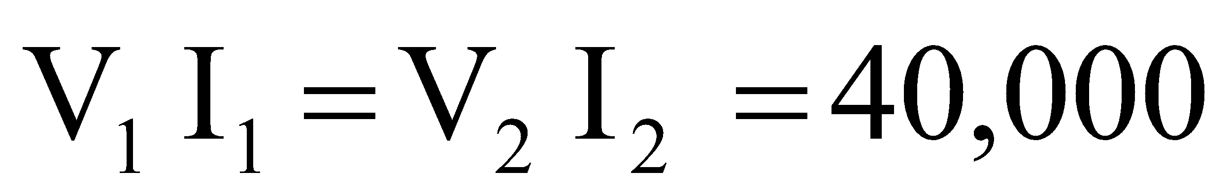

Therefore,

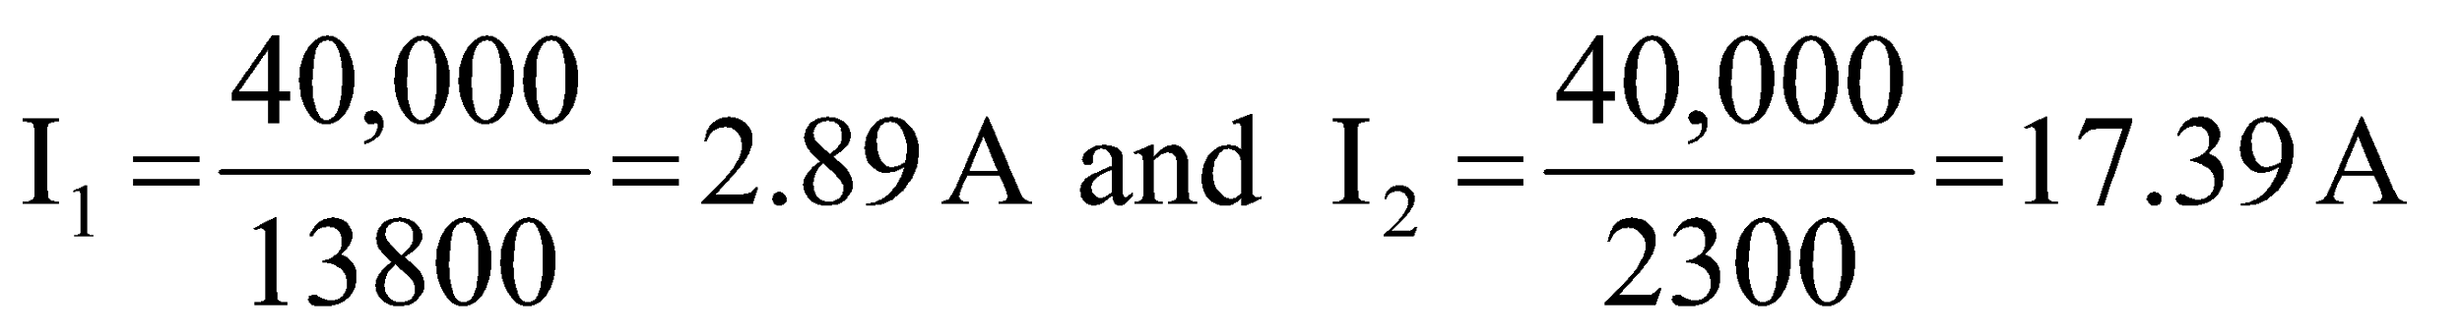
(4 marks)
{

Load impedance referred to the l.v. side

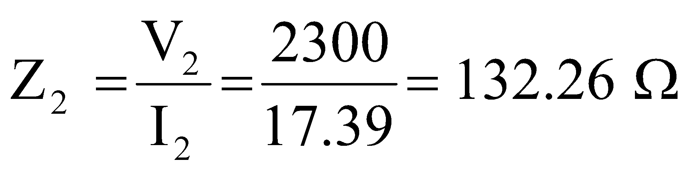

Load impedance referred to the h. v. side

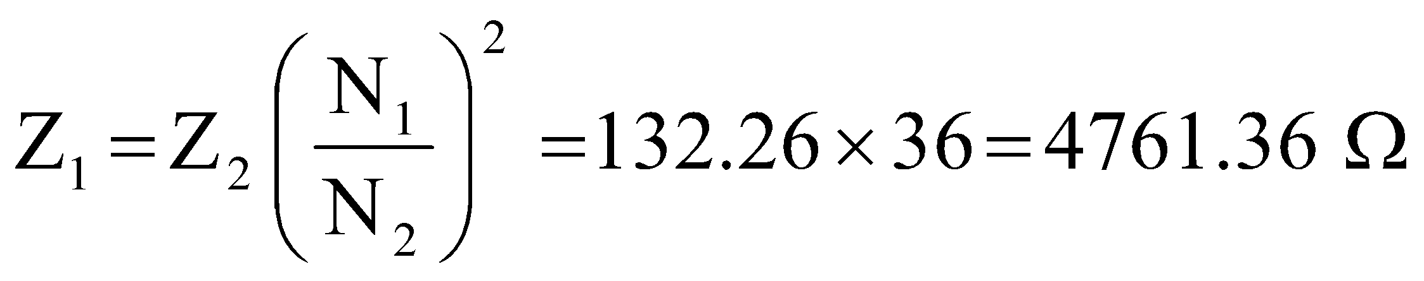
(4 marks)

The above values are referred to HV side

Resistance and reactance referred to LV side:
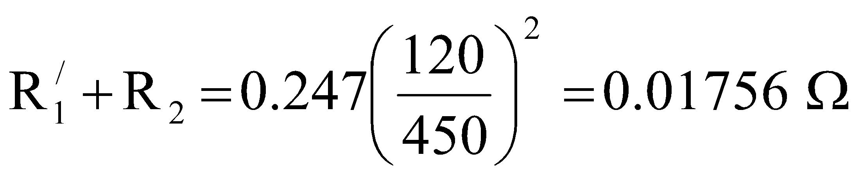
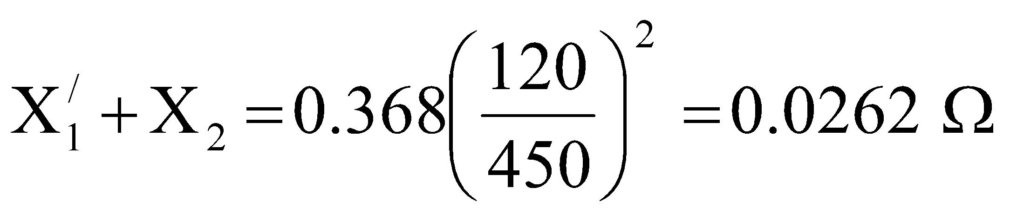
(4 marks)
[Total : 25 marks]
{
{
{
Q3. (a) Discuss the following:
{
- Force on a current carrying conductor
(10 marks)
{
{
(b) With the help of a suitable diagram explain the operating principle of an elementary stepper motor.
(15 marks)
[Total : 25 marks]

A3.

The power loss that takes place in the core of an electrical machine is known as core loss or iron loss. Iron loss is of two types viz. hysteresis loss and eddy current loss.

Hysteresis loss
Transformers and most electric motors operate on alternating current. In such devices the flux in the iron changes continuously both in value and direction. The magnetic domains are therefore oriented first in one direction, then the other, at a rate that depends upon the frequency.
If we plot the flux density B as a function of H, we obtain a closed curve called hysteresis loop.
The magnetic material absorbs energy during each hysteresis cycle and this energy is dissipated as heat. The amount of heat released per cycle is equal to the area of the hysteresis loop. To reduce hysteresis losses, we select magnetic materials that have a narrow hysteresis loop, such as the grain-oriented silicon steel used in the cores of transformers.
Eddy current loss
From Faraday’s law we see that time varying magnetic fields give rise to electric fields. In magnetic materials these electric fields result in eddy currents, which circulate in the core material. The I²R loss associated with eddy currents is known as eddy current loss.

The eddy current loss can be reduced by splitting the core into thin sections and insulating the sections from one another. The voltage induced in each section is much less than what it was before, with the result that the eddy currents and the corresponding losses are considerably reduced.
(10 marks)
{
{

Elementary stepper motor
A very simple stepper motor is shown in Fig.. It consists of a stator having three salient poles and a 2 pole rotor made of soft iron. The windings can be connected to a DC power supply by means of three switches A, B, C. When the switches are open, the rotor can take up any position. However, if switch A is closed, the resulting magnetic field created by pole 1 will attract the rotor and so it will line up as shown. If we now open switch A and simultaneously close switch B, the rotor will line up with pole 2. In doing so, it will rotate counterclockwise (ccw) by 600. Next, if we open switch B and simultaneously close switch C, the rotor will turn ccw by an additional 600, this time lining up with pole 3. Clearly, we can make the rotor advance ccw in 600 steps by closing and opening the switches in the sequence A, B, C, A, B, C…Similarly, we can make the rotor advance clock wise (cw) by operating the switches in the reverse sequence A,C,B,A,C,B.
(8 marks)

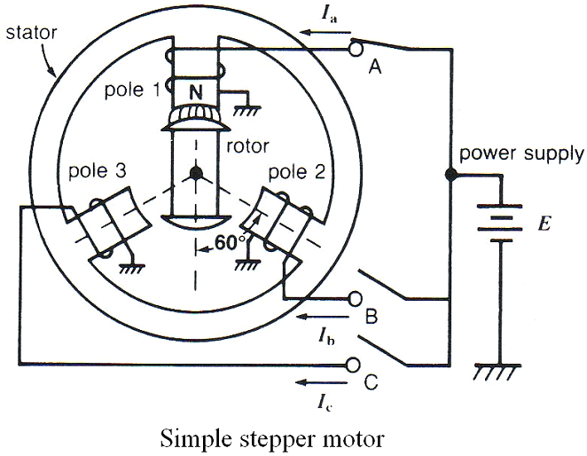
(7 marks)
[Total : 25 marks]
{
{
{
Q4. (a) Draw and explain the per phase equivalent circuit of a three phase induction
motor referred to the stator. (12 marks)
{
{
(b) A 3 phase, 4 pole, 50 Hz induction motor has a slip of 3% . The rotor has a resistance of 1Ω and standstill reactance of 4Ω,
{
(i) Calculate the speed of the motor
{
- Find out the frequency of rotor EMF
{
(iii) Calculate the power factor of rotor circuit at standstill and at a speed of
1400 r.p.m.
(13 marks)
[Total : 25 marks]
{
A4.
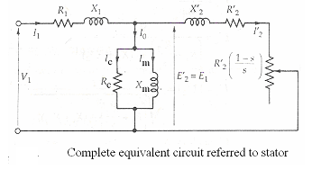

(6 marks)

where
V₁ = stator terminal voltage per phase
E₁ = counter EMF generated by resultant air gap flux per phase
I₁= stator current
R₁= stator resistance per phase
X₁ = stator leakage reactance per phase
R_{C}= core loss reistance
X_{m}=magnetizing reactance

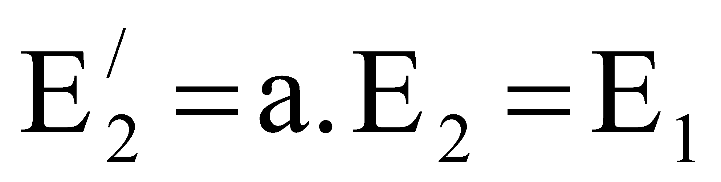
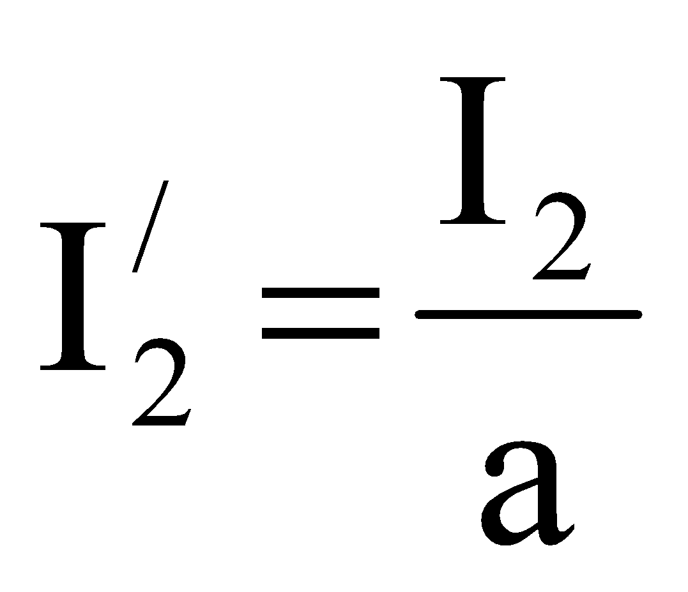
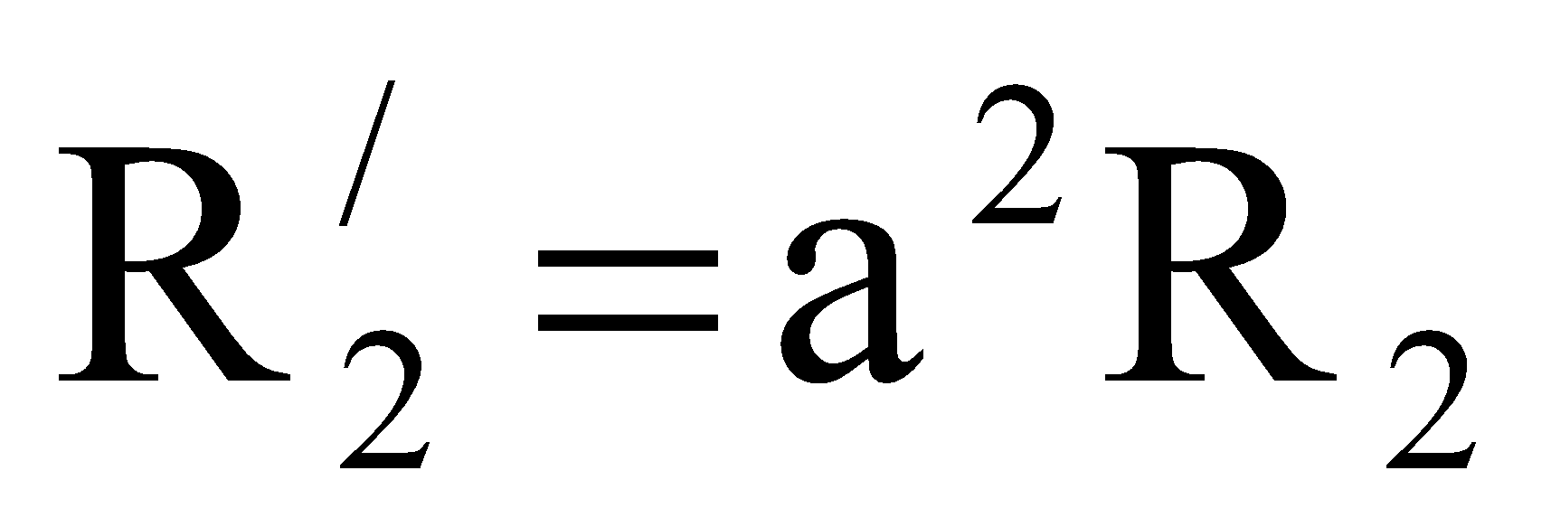
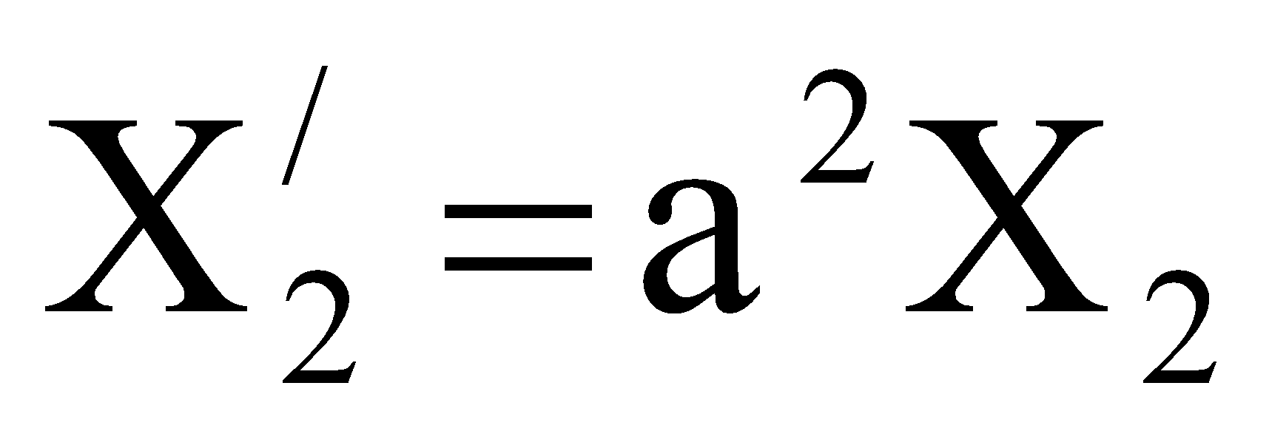

where 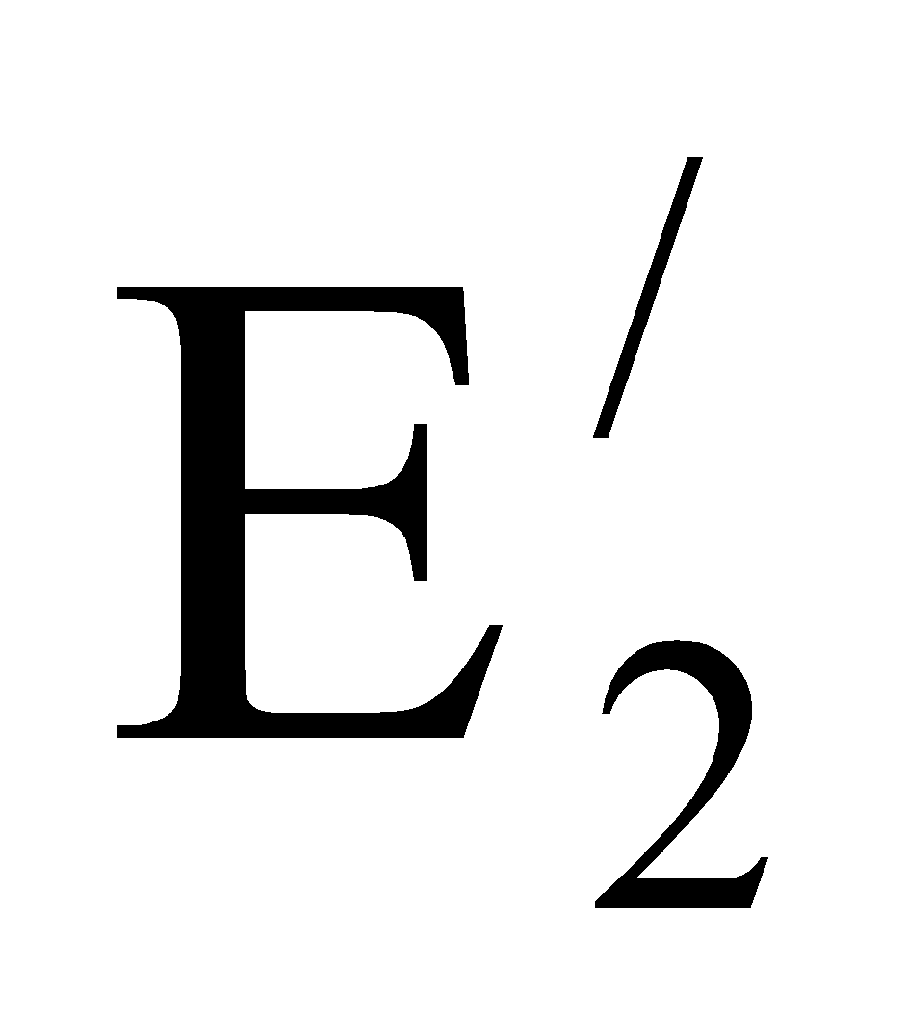, 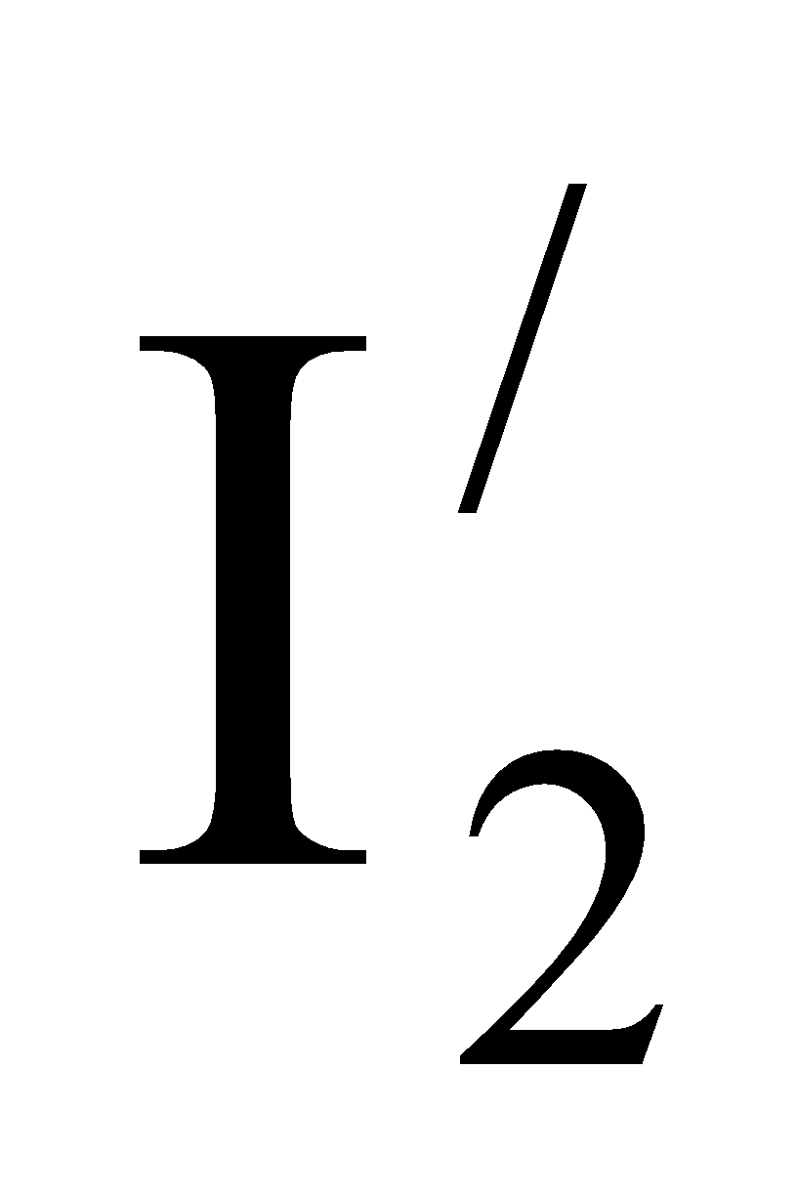, 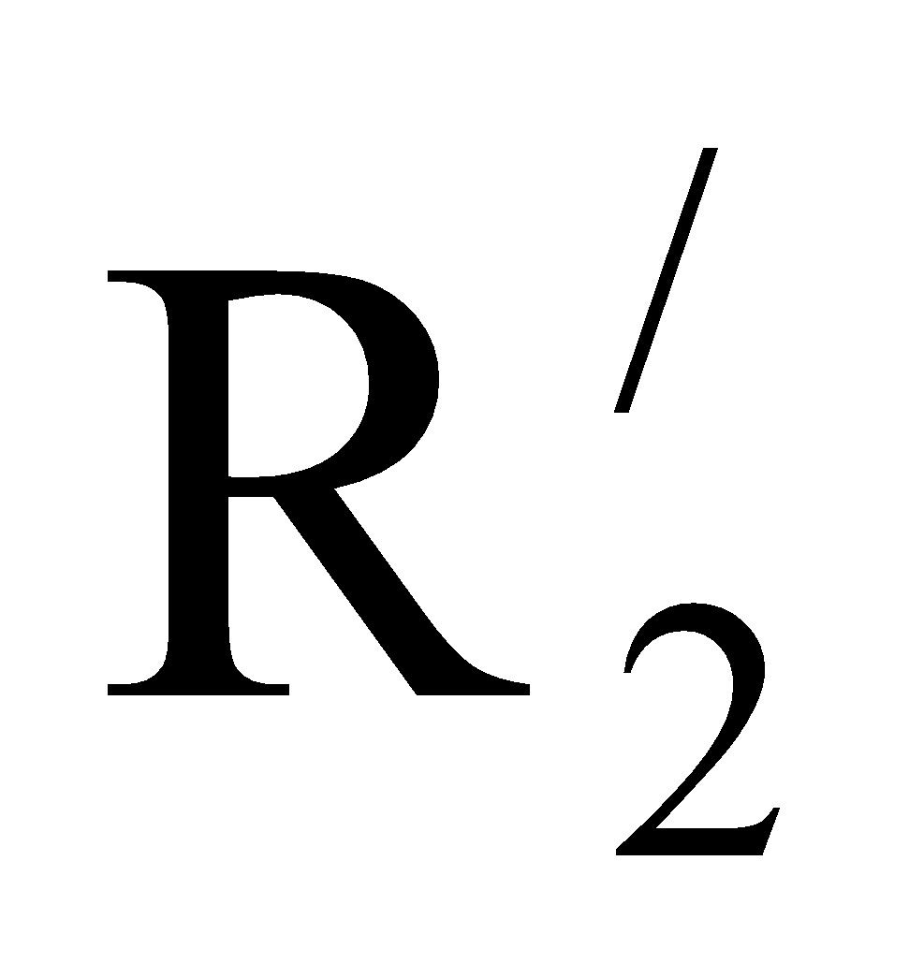and 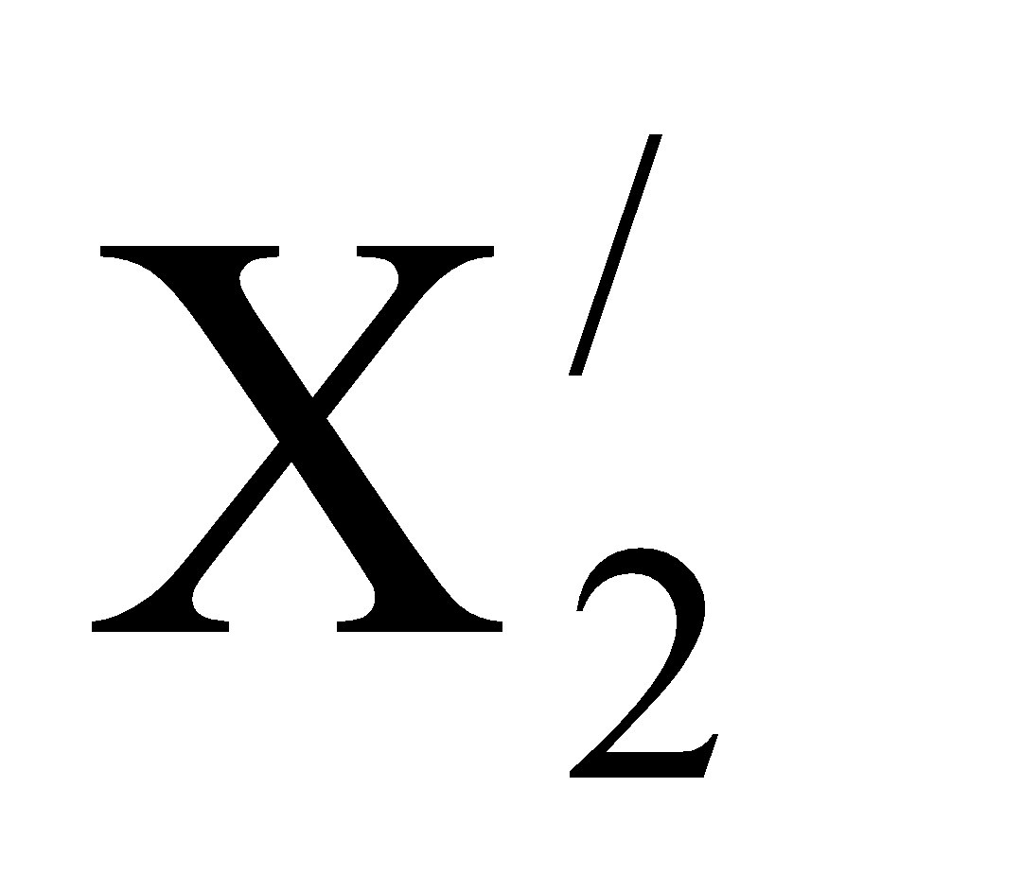are the rotor quantities referred to the stator.
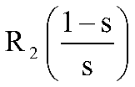
= electrical equivalent of mechanical load on motor.
(6 marks)
{
{

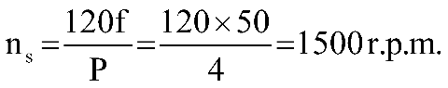

s = 3% = 0.03

Speed of motor

(2 marks)
{

Frequency of rotor EMF
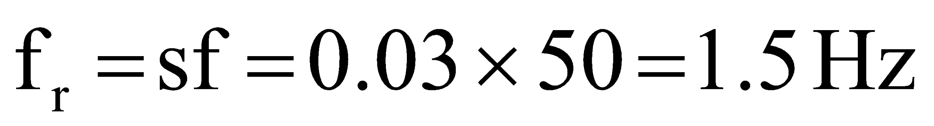
(2 marks)
{

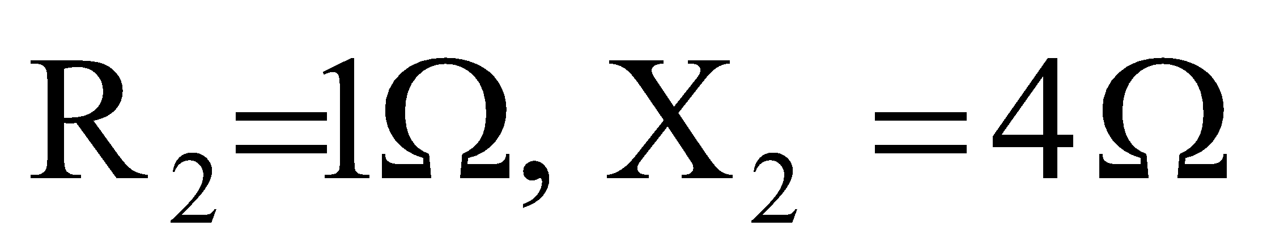

Rotor impedance at standstill

Power factor at standstill

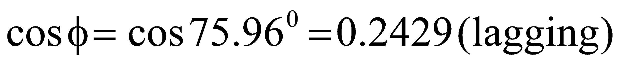
(4 marks)

Slip at a speed of 1400 r.p.m.

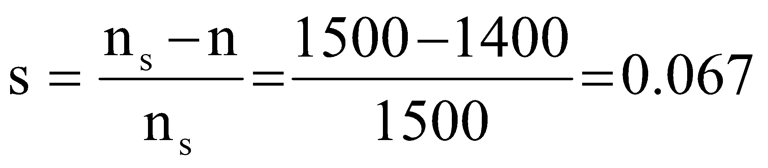

Rotor impedance at s= 0.067

Power factor

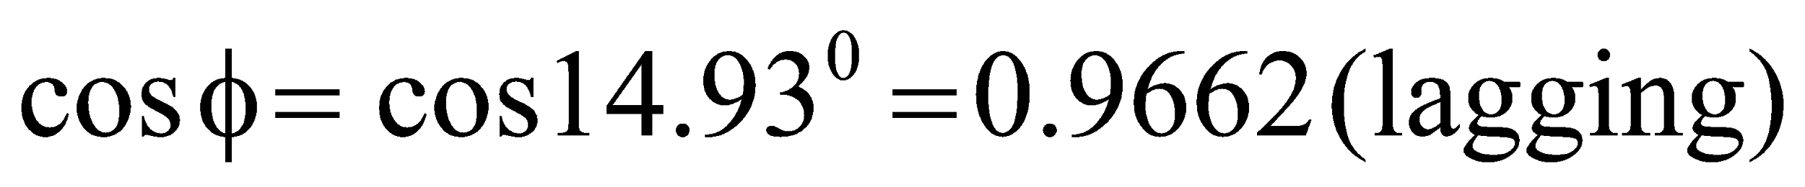
(5 marks)
[Total : 25 marks]

